Professional Research Project 2 | Decision Log
Decision Log - Choosing the Training Dataset
Decision Log Entry | 2
Project | Fine-Tuning for Guarani Mbya
Document type | Decision Log
Current LO stage | Analyzing
Main question | Which dataset should I use as the main training dataset for my low-resource fine-tuning experiment?

0. Context: Why does this question exist?
After choosing the Fine-Tuning for Guarani Mbya project, I needed to decide which dataset I should use for the actual fine-tuning experiment.
This decision matters because the dataset determines what the model can learn, how realistic the experiment is, and how trustworthy the evaluation can be. My project is inspired by Guarani Mbya, but I do not want to use sensitive Indigenous community data without permission. Therefore, I needed a safe public dataset that still allows me to test the main technical question:
Can a small fine-tuned model adapt to limited language data, generalize to unseen examples, or does it mostly memorize the training data?
Without this decision, I could not continue with cleaning, splitting, training, or evaluation.

1. My research question
Which dataset should I use as the main training dataset for my low-resource fine-tuning experiment?

2. Current LO stage
☑ Analyzing □ Advising □ Designing □ Realizing □ Managing
This decision mainly belongs to Analyzing because I compared dataset options, checked their fit with my project goal, and tested the final dataset through loading, cleaning, and splitting.

3. What makes a good decision here?
My criteria for success were:
Criterion | Meaning for this decision
Suitable as training data | The dataset should contain real text suitable for language model fine-tuning, not only benchmark-style or evaluation-style material.
Low-resource dataset size | The dataset should stay around 1,000 to 5,000 usable examples, and the chosen sample should be realistic for training.
Realistic for 19 days | The dataset should not add unnecessary language-pair or machine translation complexity.

4. What I decided
I decided to use Guarani Wikipedia from wikimedia/wikipedia, subset 20231101.gn, as my main training dataset.
I will use 3,000 cleaned examples from the available cleaned data. FLORES+ will not be used as training data. It will only remain as an optional evaluation reference if it fits the final setup.

5. Why this decision

Method I used
I first compared two dataset options: FLORES+ and AfroLingu-MT. These were my first options at the start of the dataset selection process. Guarani Wikipedia was not part of my original options; I found it later after realizing that FLORES+ was not suitable as the main training dataset.
To make the decision, I checked whether each dataset matched the goal of my project, whether it was realistic for 19 days, whether it was safe to use, and whether it could support a fine-tuning experiment.
After that, I tested Guarani Wikipedia in Python. I loaded the dataset, inspected sample rows, cleaned the data, visualized the before/after cleaning result, selected 3,000 examples, and created train, validation, and test files.

What I found
FLORES+ first looked like a good option because it is structured, multilingual, documented, and connected to low-resource language work. It also seemed easier to explain in a portfolio than collecting language data myself.
However, after checking it more carefully, I realized that FLORES+ is better used as benchmark-style or evaluation-style data than as the main training dataset for this project.
Technically, I could split FLORES+ datatset into train, validation, and test sets. However, that would not solve the main issue. My project is not mainly about machine translation benchmarking. It is about testing whether a small model can adapt to limited real text data, generalize to unseen examples, or mostly memorize the training data.
If I used FLORES+ as training data and later evaluated the model on similar benchmark-style material, the results could become less meaningful. It could look like the model generalizes well, while the experiment might be too close to the evaluation setup. That would make it harder to clearly show whether the model learned patterns or memorized examples.
AfroLingu-MT was also related to low-resource language work, but it would shift the project toward African machine translation. That adds extra complexity because I would need to choose a language pair and work more in a machine translation direction. For a 19-day project, that would move the scope too far away from my Guarani-inspired fine-tuning goal.
After rejecting FLORES+ as training data, I searched for a real Guarani text corpus and found Guarani Wikipedia. This dataset contains real Paraguayan Guarani text and is more suitable for language model fine-tuning than a benchmark-style dataset.
The dataset had 5,519 rows before cleaning and 3,535 rows after cleaning. This fits my expected low-resource range. I then selected 3,000 examples for the first version of the experiment.

Evidence & artifacts
- @Dataset_selection_flow.pdf - This document explains how my dataset choice developed from FLORES+ and AfroLingu-MT toward Guarani Wikipedia. It also explains why FLORES+ is not used as training data and why Guarani Wikipedia became the final training dataset.
- @01_cleaning_and_split.html - This notebook shows that I loaded the Guarani Wikipedia dataset, inspected the rows, cleaned the text, visualized the cleaning result, selected 3,000 examples, and created train, validation, and test files.
- 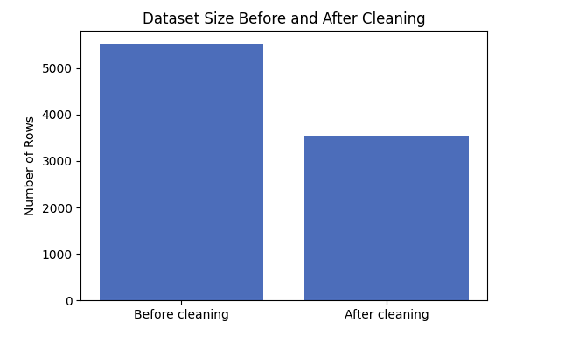
This screenshot shows the before/after cleaning result. It supports the cleaning decision because the dataset was reduced from 5,519 rows to 3,535 rows.
- 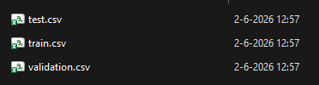
This screenshot shows the processed train.csv, validation.csv, and test.csv files.

What this means
The comparison showed that my first dataset idea was reasonable, but not final. FLORES+ looked strong at the beginning because it was structured and connected to low-resource language work. However, it was not the best main training dataset for my fine-tuning goal.
Guarani Wikipedia became the stronger choice because it contains real text, can be cleaned in Python, stays within the expected low-resource size, and allows me to continue toward model training and evaluation.

So I decided
I decided to use cleaned Guarani Wikipedia as the main training dataset, select 3,000 examples for the first version, and keep FLORES+ only as an optional evaluation reference instead of using it for training.

6. Does this hold up?
Criterion | Result | Short explanation
Suitable as training data | Achieved | Guarani Wikipedia contains real article text, so it is more suitable for fine-tuning than FLORES+, which is better used as benchmark-style or evaluation-style data.
Low-resource dataset size | Achieved | After cleaning, the dataset had 3,535 usable rows. I selected 3,000 examples, which stays inside the expected low-resource range of 1,000 to 5,000 examples.
Realistic for 19 days | Achieved | Guarani Wikipedia keeps the project focused on cleaning, fine-tuning, and evaluation. AfroLingu-MT would add extra language-pair and machine translation complexity.

Assumptions
- I assume that 3,000 cleaned examples are enough for a first low-resource fine-tuning experiment.
- I assume that Wikipedia text is useful enough for testing model adaptation, even though it is encyclopedic and not natural conversation text.

What surprised me
The main surprise was that FLORES+ looked like the best option at the beginning, but became weaker after I thought more carefully about training versus evaluation.
I also found it surprising that the cleaning step removed many rows. However, this made sense after inspecting the data, because many Wikipedia entries can be very short and do not provide enough language context for fine-tuning.

Limitations that still remain
- Wikipedia text is encyclopedic, not natural writing assistant conversation text.
- I still need to choose a small model that can realistically work with my hardware and project time.
- If no language expert can review the output, I need to focus the evaluation mainly on technical behavior, memorization, and generalization checks.

7. What this unlocks
This decision allows me to move from dataset selection to model selection. The next Decision Log will focus on which small pre-trained model I should use for fine-tuning, based on my available hardware and project time.

